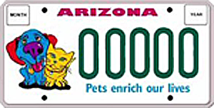

2025-2026 SPAY AND NEUTER PET FRIENDLY LICENSE PLATE GRANT REPORTING FORM

PLEASE EMAIL TO: azpetplates@gmail.com or Info@azpetplates.org

Initial Report: Must be emailed by April 30th, 2026

Final Report: Must be emailed by August 15th, 2026

(Final Report Must Include Initial Report Data)

Organization Name:

Address:

Contact Person:__________________________ Contact Telephone:
Contact email:

HOW DID YOU SPEND THESE GRANT FUNDS (DO NOT INCLUDE ADDITIONAL FUNDS meaning co-pays, donations, operating funds, other funding used to pay for spay/neuter surgeries)

Grant Amount Received $______________________________________

County of Project (for this report):

Designated Program: Public pets Feral Cats Sheltered Animals - Government/Nonprofit

Reporting Period (month to month): __________________ Grant Amount Spent: $________________

Dogs Sterilized: Male______________ Female:___________________

Cats Sterilized: Male______________ Female: __________________

ACTIVITY ATTACHMENTS FOR FINAL REPORT ONLY – Attach brochures, flyers, copy of vouchers, newsletters, website page and/or other items representing s/n services offered under these funds and/or acknowledging Pet Friendly License Plate Grant, including options for support – Pet Plate purchase and AZ Personal Income Tax Donation option.

